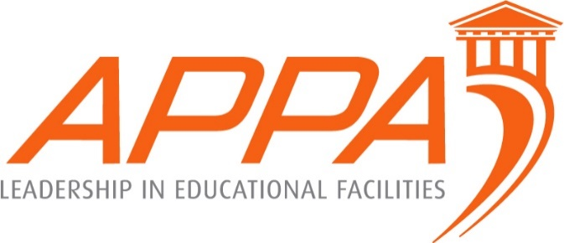
APPA Supervisor’s Toolkit
Training Session Announcement at
The University of Regina is sponsoring a Supervisor’s Toolkit November 6th – 9th, 2018.
The tuition for this four day training course is $380 per person (see schedule below.) Travel, Per diem, etc. are not covered by the registration fee. Lunch will be included in the training.
To register, contact Emmet Boyle via email at Emmet.Boyle@uregina.ca or by phone at (306) 585-4419. Payment can me made via check to University of Regina and can be mailed to:
Emmet Boyle
Director of Maintenance & Utilities
University of Regina
3737 Wascana Parkway
Regina, Saskatchewan
S4S 0A2
The class will be limited to the first 30, so register early! All registrations must be received by October 22, 2018.
Classes will be held at University of Regina, College West Building room 113.
Paid parking is available on campus in Lot #2 (see link below).
https://www.uregina.ca/fm/parking/assets/images/page-pictures/Main%20Campus%2013Dec16.pdf
Lodging:
Residence Services may have dorm rooms available: https://resiis.cc.uregina.ca/ConferencePortal/Modules/Conference/ShortStayConferenceSelector.aspx?Params=L9ezxPcQnQtgRNsm7RpNB4sWmhgL31mSP4x9ZRyf8UU%3d
OR
To view the preferred CAUBO rates for 2017-2018 for Canadian hotels: https://www.caubo.ca/web_listing_2017-18_may-2018/

November 6th – November 9th, 2018
Supervisor Toolkit
Course Agenda

Tuesday (November 6th)
8:15 – 4:15
Module 1: Supervision - What Is It?
Lunch
Module 2: It’s More Than Administrivia
Wednesday (November 7th)
8:15 – 4:15
Module 3: Communication - Let’s Talk!
Lunch
Module 4: If it Weren’t for the People
Thursday (November 8th)
8:15 – 4:15
Module 5: Motivation and Performance
Lunch
Module 6: Customer Service Triangle

Friday (November 9th)
8:15 – 2:00
Module 7: Leadership – Tools for Success
Lunch
Awards

