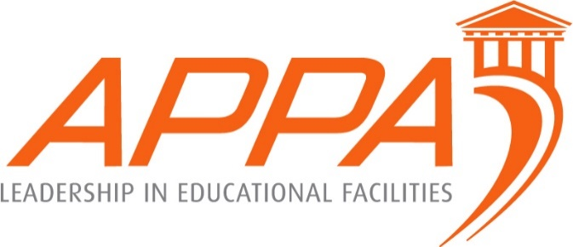
APPA Supervisor’s Toolkit
Training Session Announcement at

Idaho State University is sponsoring a Supervisor’s Toolkit from August 7-10.
The tuition for this four day training course is $275 per person (see schedule below.) Travel, Per diem, etc. are not covered by the registration fee. Lunch will be included in the training.
To register, contact Mark Cates via email at catemark@isu.edu or by phone at 208-282-4502. Payment can me made via check to Idaho State University Facilities Services and can be mailed to:
Attn: Mark Cates
Facilities M&O
Mail Stop 8137
Idaho State University
Pocatello, Idaho 83209
For Interdepartmental Billing or ISU Employees only: Please submit an online work order or email and provide an index code. Your account will be charged automatically.

The class will be limited to the first 45, so register early! All registrations must be received by July 23, 2018.
Classes will be held at the Student Union building, 1065 South 5th Pocatello Idaho Parking passes will be handed out at 7:45 am on the first day.
Nearby Hotels
Red Lion: https://www.redlion.com/pocatello
Choice Hotels: https://www.choicehotels.com/idaho/pocatello/clarion-hotels/id057?source=gyxt
La Quinta: http://www.laquintapocatello.com/?cid=local_6855
Holiday Inn Express: https://www.ihg.com/holidayinnexpress/hotels/us/en/pocatello/pihex/hoteldetail
Towne Place Suites: https://www.marriott.com/hotels/travel/idats-towneplace-suites-pocatello/?scid=bb1a189a-fec3-4d19-a255-54ba596febe2

August 7 - 10, 2018
Supervisor Toolkit
Course Agenda

TUESDAY AUGUST 7th
8:00 – 4:00
Module 1: Supervision - What Is It?
Lunch
Module 2: It’s More Than Administrivia
WEDNESDAY AUGUST 8th
8:00 – 4:00
Module 3: Communication - Let’s Talk!
Lunch
Module 4: If it Weren’t for the People
THURSDAY AUGUST 9th
8:00 – 4:00
Module 5: Motivation and Performance
Lunch
Module 6: Customer Service Triangle

FRIDAY AUGUST 10th
8:00 – 2:00
Module 7: Leadership – Tools for Success
Lunch
Awards

